Fairbanks Bar (a.k.a. Fairbanks Cigar Store)
536 (542) 2nd Ave 1935 – 1983
409 2nd Ave. 1983 - 1984

Fairbanks Cigar Store in 1935
UAF-2006-103-188

Fairbanks Daily News–Miner 03/06/1936

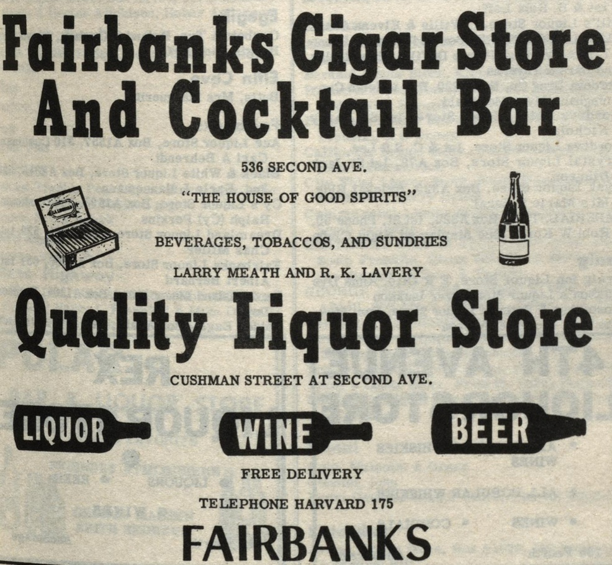
Alaska Business Directory 8

Alaska Business Directory
by William Tewkesbury - 1948

Guide to Alaska and the Yukon by Lou Jacobin - 1961

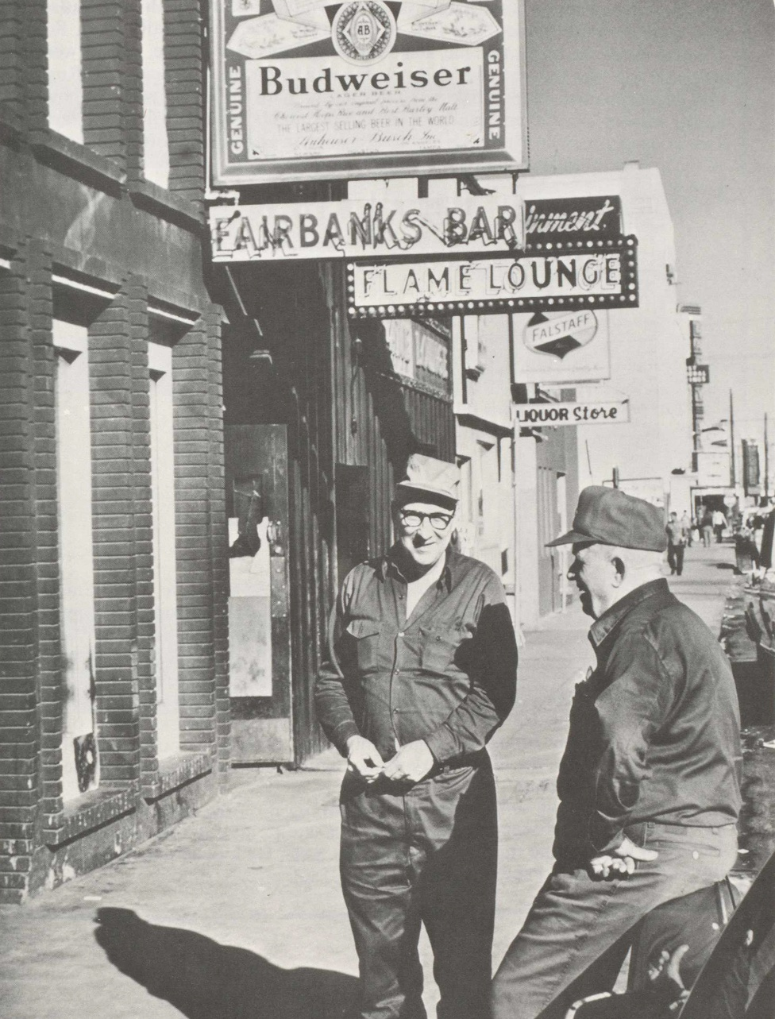

Alaska: The Sophisticated Wilderness
By Jon Gardney - 1977

Fairbanks Daily News-Miner 06/09/1983

Closing party
Fairbanks Daily News-Miner 11/01/1984

